Welcome to the PatternAgents Agent-DA7280 FeatherWing
A Dialog Semiconductor DA7280 Haptic controller based FeatherWing with an integrated ADXL345 Accelerometer, and current-measurement capabilities.

Getting Started :
The Agent-DA7280 FeatherWing is very flexible, and there are a number of different ways to power and use the board, with both Adafruit Feather compatible connectors and Seeed Grove compatible connectors.
Using a Seeed Grove System Compatible CPU :
Use a standard Grove Cable to connect the Agent-DA7280 FeatherWing to Compatible CPU, as shown below :
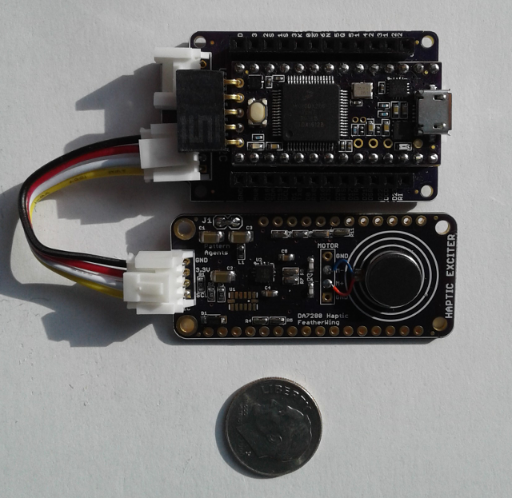

We recommend the use of "Buckled Cables" , which include a locking mechanism to avoid disconnection due to the large vibrations the DA7280 is capable of producing.
Using an Adafruit Feather compatible CPU :
The Agent-DA7280 FeatherWing is compatible with most 3.3Volt Adafruit Feather CPU boards that support the I2C bus.
NOTE: While we offer the Agent-DA7280 FeatherWing with Female Feather connectors as an option for maximum user flexability, we strongly recommend using soldered connections between the
Feather CPU board and the the Agent-DA7280 FeatherWing - due to the large vibrations the DA7280 is capable of producing.

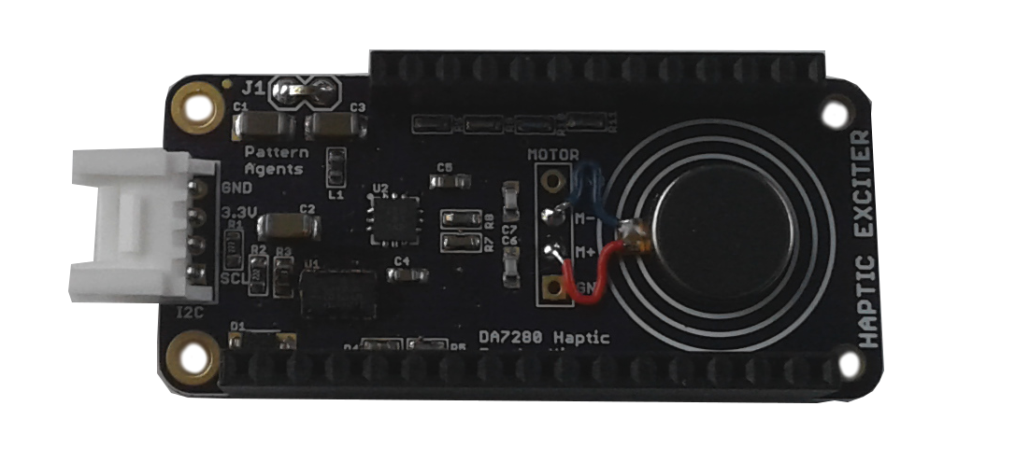
Mounting the Agent-DA7280 FeatherWing :
The Agent-DA7280 FeatherWing requires a weighted base, also known as a "Slug", or "Sled" to operate effectively (i.e. it requires a mass to move and vibrate). Often this can be the "package" or case of your product, or sometimes rear surface of an LCD or OLED touchscreen is used.
Your application may require some tuning of the placement and weight used for optimum effect, and we offer consulting services if you require some assistance with tuning.

Current Measurement with the Agent-DA7280 FeatherWing :
The Agent-DA7280 FeatherWing power jumper "J1" is typically a solid wire/soldered connection to avoid any vibration issues or power disconnection while it is operating.
While we don't recommend that "J1" normally be populated with a Two(2) pin jumper, this is possible for in-situ connection of a current meter to monitor power comsumption during operation.
Safe Handling Precautions :
1) Always remove/unplug all power before inserting or removing peripherals.
2) Always ground yourself by touching a ground point before handling your boards.
3) Use a static safe bag when transporting your Agent-DA7280 FeatherWing board.
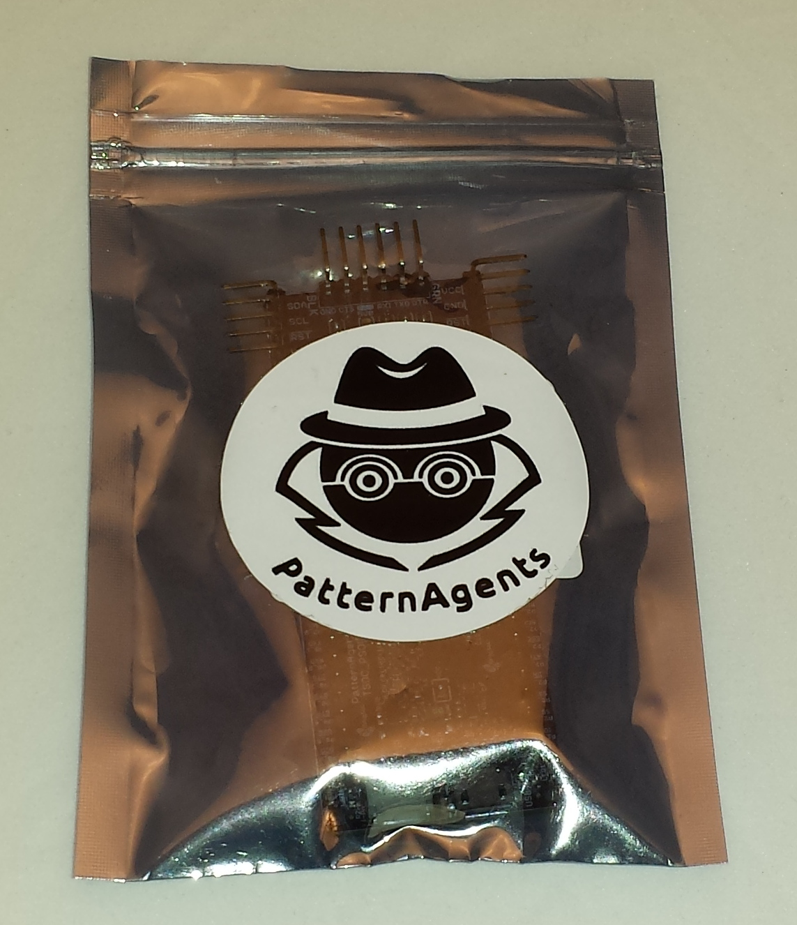

Adding Grove Peripherals :
The Agent-DA7280 FeatherWing board supports both Grove and Adafruit Feather peripherals.
1) Grove connectors are polarized, and can only be plugged in one way.
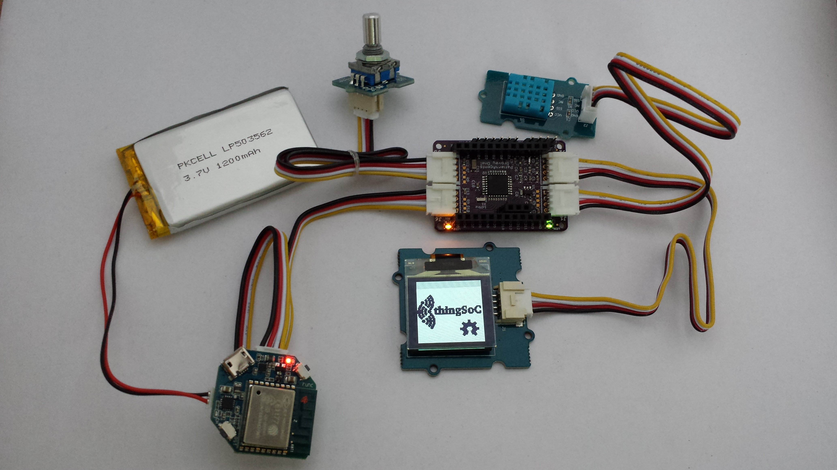

PatternAgents Agent_DA7280 FeatherWing Features :
Dialog Semiconductor DA7280 Haptic controller based FeatherWing with an integrated ADXL345 Accelerometer, and current-measurement capabilities :
- Dialog Semiconductor DA7280 in QFN12 package
- Analog Devices ADXL345 3-D Accelerometer
- Adafruit Feather Compatible Module
- Grove System I2C Compatible Module
- Integrated Current Measurement connection
- ERM Haptic Actuator Support
- LRA Haptic Actuator Support
- 3.3 Volt operation
- Mass Sled Mounting Holes

Agent_DA7280 FeatherWing Default I2C Addresses :
ADXL345 Accelerometer = 0x53
DA7270 Haptic Controller = 0x4A
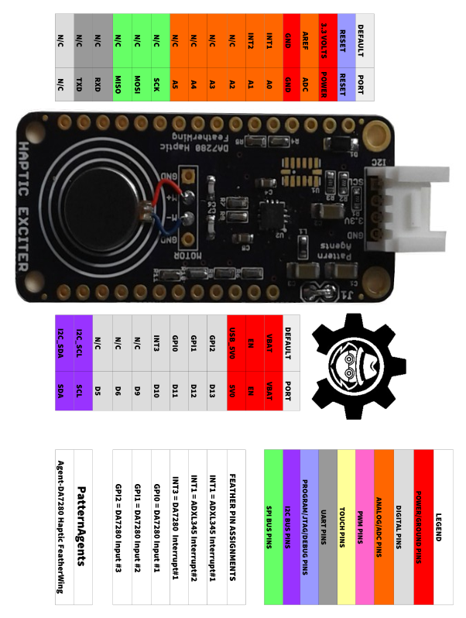
PatternAgents Agent_DA7280 FeatherWing Arduino Examples :
We are working on developing a new Arduino library to support the DA728x series,
and it will be available at https://github.com/PatternAgents/Haptic_DA7280
See the examples at https://github.com/PatternAgents/Haptic_DA7280/tree/master/examples/

For more documentation and more information :

Complete documentation, including schematics, layouts, gerbers, and Bill of Materials (BOM) are available on the PatternAgents Github repository. There is also a project Wiki and Bug Tracking System available for asking questions and getting more information at :
https://github.com/PatternAgents/Agent-DA7280-FeatherWing

